Chapter 17, Solution 69.

The schematic is shown below. In the Transient dialog box, set Print Step = 0.05 s, Final Time = 120, Center Frequency = 0.5, Output Vars = V(1) and click enable Fourier. After simulation, we obtain V(1) as shown below. We also obtain an output file which includes the following Fourier components.

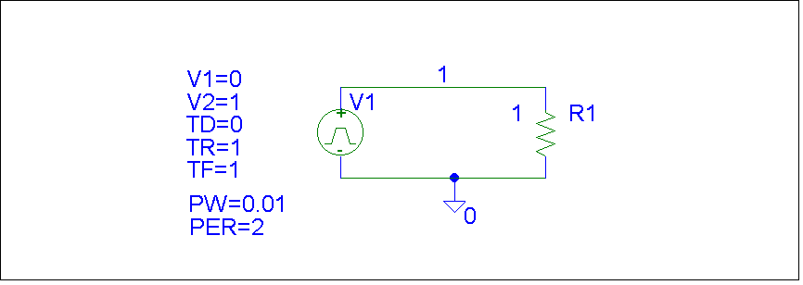

FOURIER COMPONENTS OF TRANSIENT RESPONSE V(1)

DC COMPONENT = 5.048510E-01

HARMONIC FREQUENCY FOURIER NORMALIZED PHASE NORMALIZED
NO (HZ) COMPONENT COMPONENT (DEG) PHASE (DEG)

1 5.000E-01 4.056E-01 1.000E+00 -9.090E+01 0.000E+00
2 1.000E+00 2.977E-04 7.341E-04 -8.707E+01 3.833E+00
3 1.500E+00 4.531E-02 1.117E-01 -9.266E+01 -1.761E+00
4 2.000E+00 2.969E-04 7.320E-04 -8.414E+01 6.757E+00
5 2.500E+00 1.648E-02 4.064E-02 -9.432E+01 -3.417E+00
6 3.000E+00 2.955E-04 7.285E-04 -8.124E+01 9.659E+00
7 3.500E+00 8.535E-03 2.104E-02 -9.581E+01 -4.911E+00
8 4.000E+00 2.935E-04 7.238E-04 -7.836E+01 1.254E+01
9 4.500E+00 5.258E-03 1.296E-02 -9.710E+01 -6.197E+00

TOTAL HARMONIC DISTORTION = 1.214285E+01 PERCENT

